

**INTERNATIONAL SCHOOL**

**CAPSTONE PROJECT 1**

**CMU-CS 246 TIS**

**USER INTERFACE DESIGN DOCUMENT**

Version: 1.1

**CALCULATOR – CG1**

**Mentor: Nguyen Dang Quang Huy**

***Team Member*:**

Huy, Mai Vo

Son, Le Duc Hung

Binh, Tran Phuc

Duong, Vu Cong

Phuc, Tran Van

**Approved by Huy Nguyen Dang Quang**

**UserInterface Review Panel Representative:**

Name Signature Date

**Capstone Project 1- Mentor:**

Name Signature Date

Da Nang, 3/2025

**PROJECT INFORMATION**

|  |  |
| --- | --- |
| **Project Acronym** | CG1 |
| **Project Title** | Calculator | | | |
| **Start Date** | 2 – Mar –2025 | **End Date:** | 8 – Mar –2025 | |
| **Lead Institution** | International School, Duy Tan University | | | |
| **Team Member** | **Name** | **Email** | | **Phone** |
| 29219020140 | Le Duc Hung Son | Sonhung17012005@gmail.com | | 0976846033 |
| 29216945279 | Tran Phuc Binh | Binht7848@gmail.com | | 0337398848 |
| 29211338975 | Mai Vo Gia Huy | Maivogiahuy995@gmail.com | | 0982001627 |
| 29211148766 | Vu Cong Duong | Vud66592@gmail.com | | 0793523425 |
| 29219041264 | Tran Phuc Binh | Tranvanp652@gmail.com | | 0707389125 |

**PROJECT PLAN DOCUMENT**

|  |  |  |  |
| --- | --- | --- | --- |
| **Document Title** | User Interface Document | | |
| **Author(s)** | Group 1 | | |
| **Date** |  | **File name:** | GROUP_1_USER_INTERFACE_DESIGN_DOCUMENT |
| **URL** |  | | |
| **Access** | Project and CMU Program | | |

**SIGNATURE**

**Document Approvals:** The following signatures are required for approval of this document.

|  |  |  |  |
| --- | --- | --- | --- |
| **Mentor** | Huy, Nguyen Dang Quang | **Signature:** |  |
| **Date:** |  |
| **Scrum master** | Huy, Mai Vo Gia | **Signature:** |  |
| **Date:** |  |
| **Team member(s)** | Phuc, Tran Van | **Signature:** |  |
| **Date:** |  |
| Son, Le Duc Hung | **Signature:** |  |
| **Date:** |  |
| Duong, Vu Cong | **Signature:** |  |
| **Date:** |  |
| Binh, Tran Phuc | **Signature:** |  |
| **Date:** |  |

**DOCUMENT HISTORY**

|  |  |  |  |
| --- | --- | --- | --- |
| **Version** | **Person** | **Date** | **Description** |
| 1.0 |  |  |  |
| 1.1 |  |  |  |

**TABLE OF CONTENTS**

**I.** **INTRODUCTION 5**

1. PURPOSE 5

2. SCOPE 5

3. INTENDED AUDIENCE 5

**II.** **LIST OF USER INTERFACE 6**

1. BUSINESS FUNCTION DIAGRAM: 6

2. WEB APP 7

**III.** **DESCRIBE USER INTERFACE 8**

1.Main Screen 9

2.Calculation History 11

## 

# INTRODUCTION

## PURPOSE

* This document intended to provide a detailed description of computer management softwares
* Is the primary reference for software design, testing, and implementation.
* Make sure that all team members, including developers, testers, and project managers, have a common understanding of how to use the software.

## SCOPE

* This document helps to better understand the interface of the System, detailed specification components and function of the System.
* Provides an overview of the software steps and modules to create a complete interface.
* Support the development team to build a unified and complete interface.

## INTENDED AUDIENCE

This document is intended for the following audiences:

* Technical reviewers including:
* Scrum Master
* Product owner
* Implementers, including:
  + Developers.
  + User
  + Testers.

# LIST OF USER INTERFACE

## BUSINESS FUNCTION DIAGRAM:

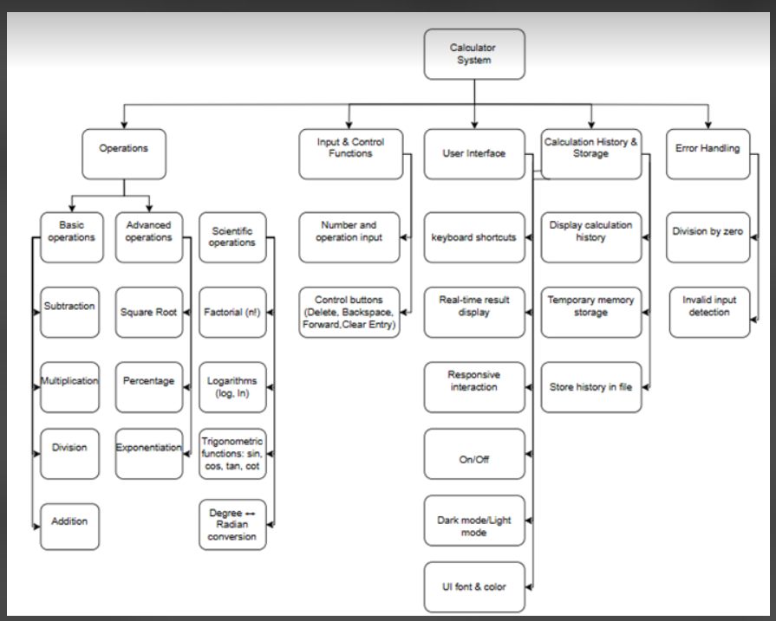

*Figure 1: Business Function diagram*

## WEB APP:

|  |  |  |
| --- | --- | --- |
| **User Interface ID** | **UI Name** | **Description** |
| UI-01 | Main Display Panel | Displays the current input, ongoing calculation, and final result in real time. |
| UI-02 | Error Notification Bar | Displays error messages when issues occur (e.g., invalid data or division by zero). |
| UI-03 | Numeric Keypad | Provides numeric buttons (0-9) and a decimal point for data input. |
| UI-04 | Basic Operation Buttons | Contains buttons for basic operations: addition, subtraction, multiplication, and division. |
| UI-05 | Advanced Operation Buttons | Contains buttons for advanced operations: exponentiation, square root, and percentage. |
| UI-06 | Backspace Button | Deletes the last entered character from the input field. |
| UI-07 | Clear Button | Clears the entire input field, resetting the current calculation. |
| UI-08 | Calculation History Panel | Displays a list of calculations performed during the session. |
| UI-09 | Power Toggle Switch | Allows the user to turn the calculator on or off. |
| UI-10 | Factorial Button(n!) | Performs factorial calculator on positive integers |
| UI-11 | Logarithm Buttons | Includes log₁₀(x) and ln(x) for base-10 and natural logarithms. |
| UI-12 | Trigonometric Function Buttons | Includes trigonometric functions: sin(x), cos(x), tan(x), and cot(x). |
| UI-13 | Angle Unit Conversion Button | Allows switching between degrees (°) and radians. |
| UI-14 | Search in History Function | |  | | --- | |  |  |  | | --- | | Enables users to search previous calculations by keyword or value. | |
| UI-15 | Delete History Line | Allows users to delete individual entries from the calculation history. |
| UI-16 | Save History to File | Automatically stores calculation history in a JSON or text file. |
| UI-17 | Dark/Light Mode Toggle | |  | | --- | |  |  |  | | --- | | Allows switching between dark mode and light mode for better user experience. | |
| UI-18 | UI Customization Options | Lets users change fonts and interface color schemes. |
| UI-19 | Keyboard Shortcuts Support | Enables users to input calculations quickly via physical keyboard shortcuts. |
| UI-20 | CE (Clear Entry) Button | |  | | --- | |  |  |  | | --- | | Clears only the current number entry without resetting the full calculation. | |
| UI-21 | Backspace Arrow (←) | Deletes the character to the left of the cursor. |
| UI-22 | Forward/Delete Arrow (→) | Deletes the character to the right of the cursor. |
| UI-23 | Copy/Paste Result Functionality | Allows users to copy results to the clipboard and paste input from the clipboard. |

*Table 1: List of Interface*

# DESCRIBE USER INTERFACE

1.**Main Screen**

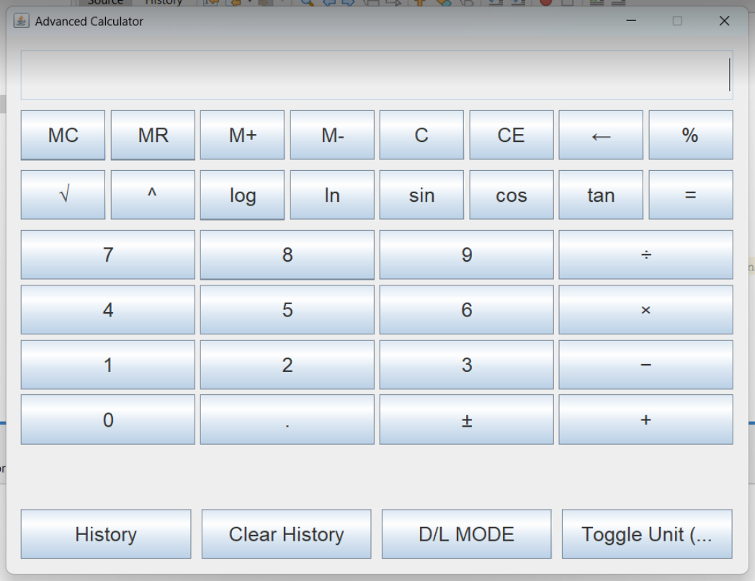

|  |  |  |  |
| --- | --- | --- | --- |
| **ID** | **Condition** | **Control Type** | **Target** |
| 1 | Enabled | |  | | --- | |  |  |  | | --- | |  |  |  | | --- | | Toggle Buttons | | Toggle power on/off for the calculator |
| 2 | Enabled | Display Field | Show current input and history |
| 3 | Enabled | Function Buttons | Clear display (C), delete entry (DEL), |
| 4 | Enabled | Function Buttons | Compute square root (√), exponentiation (x^y), calculate percentage (%) |
| 5 | Enabled | Digit Buttons | |  | | --- | |  |   Input digits (0-9) and decimal point (.) |
| 6 | Enabled | Operator Buttons | Execute arithmetic operations: division (÷), multiplication (×), subtraction (−), addition (+), and equals (=) |
| 7 | Enabled | Scientific Functions | |  | | --- | |  |  |  | | --- | | Factorial (n!), logarithm (log₁₀ x), natural log (ln x) | |
| 8 | Enabled | Trigonometric Buttons | |  | | --- | |  |  |  | | --- | | Factorial (n!), logarithm (log₁₀ x), natural log (ln x) | |
| 9 | Enabled | |  | | --- | |  |  |  | | --- | | Angle Conversion | | |  | | --- | |  |   Convert angle units: Degrees ↔ Radians |
| 10 | Enabled | History Management | Save calculation history to a JSON or text file |
| 11 | Enabled | History Search | Search previous calculations in history |
| 12 | Enabled | History Delete | Delete specific entries from calculation history |
| 13 | Enabled | Theme Toggle | Switch between Dark mode and Light mode |
| 14 | Enabled | |  | | --- | |  |  |  | | --- | | UI Customization | | Allow users to choose fonts and color schemes |
| 15 | Enabled | |  | | --- | |  |  |  | | --- | | Keyboard Shortcuts | | Allow calculations and input via keyboard (e.g., Enter for “=”, Backspace for deletion) |
| 16 | Enabled | Cursor Navigation | Support ← (Backspace) and → (Forward) to navigate and delete characters at cursor level |
| 17 | Enabled | Clipboard Interaction | Copy/Paste results or expressions via clipboard |
| 18 | Enabled | Expression Evaluation | Evaluate complex expressions (e.g., 5 + (3 * 2) - √9) |
| 19 | Enabled | |  | | --- | |  |  |  | | --- | | Error Handling | | |  | | --- | |  |  |  | | --- | | Detect and notify invalid inputs (e.g., divide by 0, √-9, syntax errors like “5++2”) | |
| 20 | Enabled | Error Feedback | Show detailed error messages to help users correct input |

*Table2:Describe the user interface*

2.**Calculation History**

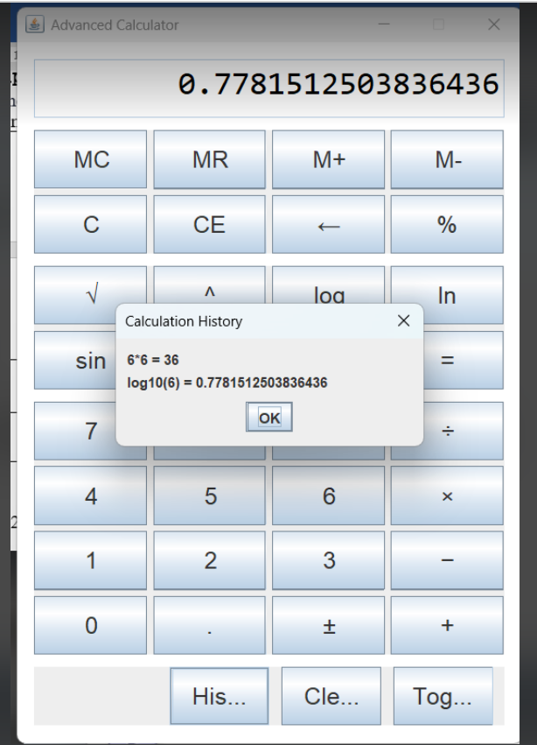

|  |  |  |  |
| --- | --- | --- | --- |
| ID | Condition | Control Type | Target |
| 1 | Press | Button | Clear History |

*Table3:Describe user interface calculation history*